Final Exam: Introduction to Robotics 16-311 Fall 2010

Name:

Team:

You have 1 hour and 15 minutes to complete the exam.

Please write all answers either on the exam

You must attempt all five problems

You can use one 8.5 x 11 inch sheet of paper of notes written in your own hand

You can use a calculator but only the “nonprogrammable” functions.

Good Luck

Question 1

Question 2

Question 3

Question 4

Question 5

Total

Problem #1 [25 pts]

The robot below has a revolute joint with angle θ at the base which rotates a prismatic joint with length s whose range of motion is 0 to 100 cm. The base joint has no limits. The robot is shown in its initial position.

There are 3 obstacles: two point obstacles at (0,50) and (0,-50), and a curved quarter circular wall with radius 75 cm.

Given the following workspace, draw the configuration space [10pts]:

Chose a metric and draw the shortest path in configuration space when the end-effector starts at (45,60) and arrives at (–45,60) [10pts]

Draw the path of the end-effector in the work space for the above shortest path [5pts].

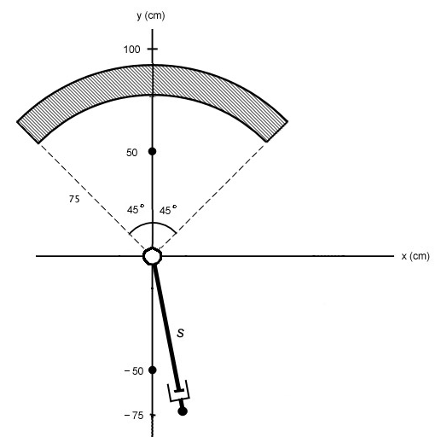

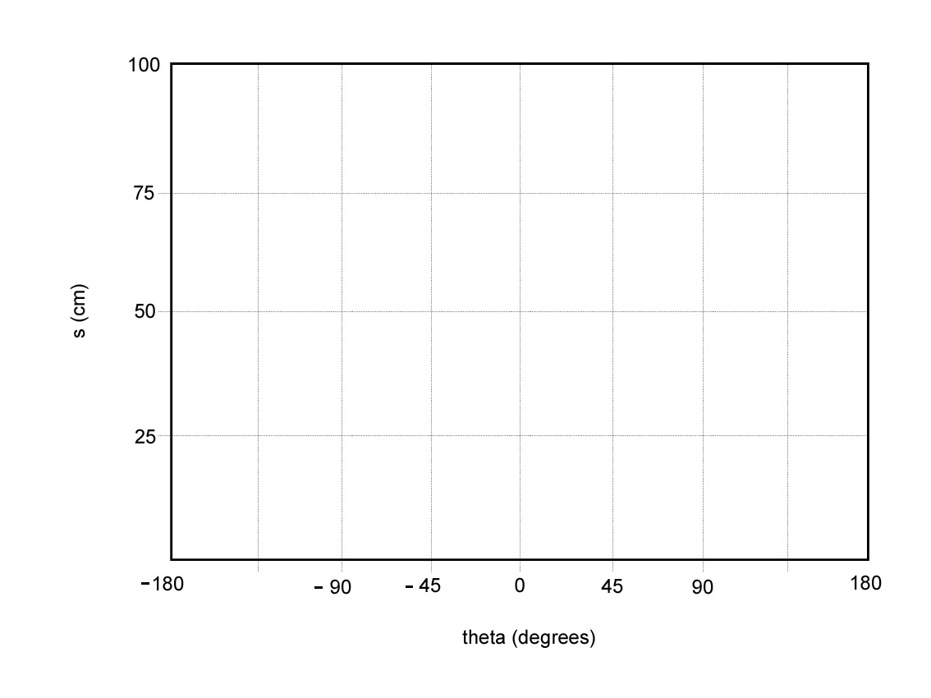
EXTRA CPSACE
Problem #2 [20 pts]

Draw or concisely describe the following:

Note: A circle is different from a disk; remember to shade in if needed. If there is no answer, write NONE. If joint limits are not specified, assume no joint limits.

A. the set of points that the end effector can reach for the two-link robot where L1 > L2

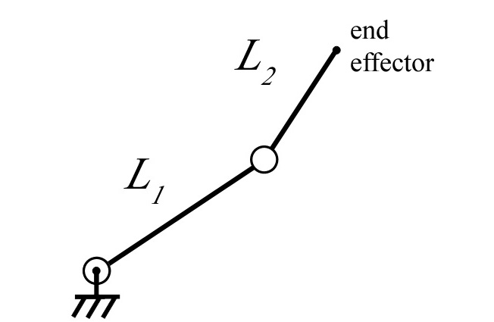

B. the set of points that the end effector can reach for the two-link robot where L1 < L2

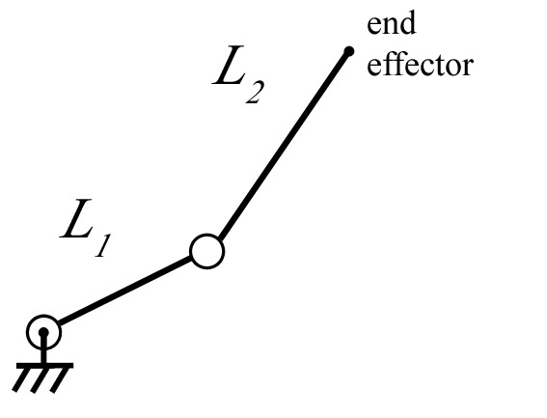

C. the set of points that the end effector can position and orient the last link for a three link manipulator where L1 > L2 > L3 and L2 + L3 > L1.

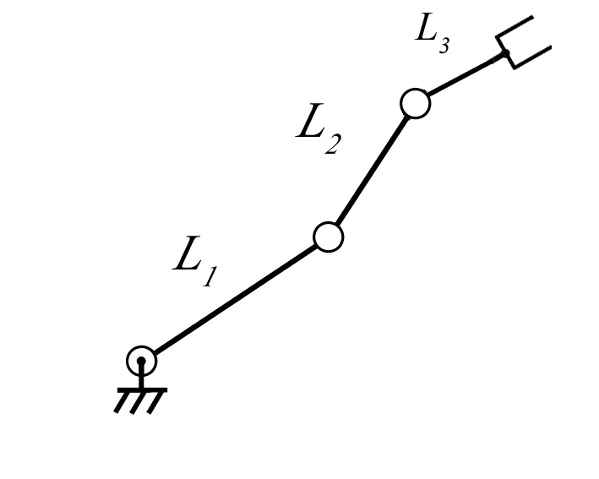

D. the set of points that the end effector can position and orient the last link for a two-link manipulator where L1 < L2

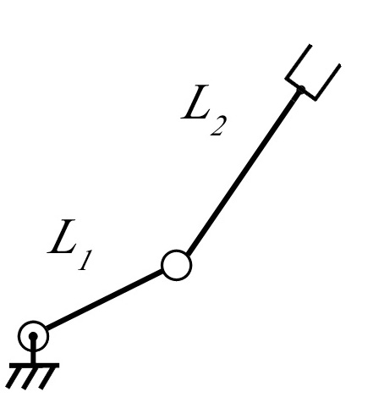

Problem #3 [25 pts]

For the following problem, consider the vehicle
θ
φ
y
x
l

- What are the state variables for this system? [5pts]

- The initial allowable motions for this system are $g1(q)=\left[\begin{matrix}0 \\ 0 \\ 0 \\ 1\end{matrix}\right],g2(q)=\begin{matrix}\text{cos}θ \\ \text{sin}θ \\ \frac{1}{l}\text{tan}φ \\ 0\end{matrix}$
To what physical motion to these correspond [5pt]

- Perform the Lie Bracket of [g1, g2] and call the result g3. To what motion does g3 correspond [5pts]

- Perform the Lie Bracket of [g1, g3] and call the result g4. To what motion does g4 correspond [5pts]

- Perform the Lie Bracket of [g2, g3] and call the result g5. To what motion does g5 correspond [5pts]

Problem 4: Inverse Kinematics [20pts]
The following mobile manipulator consists of a base that can move in the plane and an arm with two prismatic joints (rotational and extensible) and a revolute joint. The arm moves in
3-space, but the base can only move on the floor plane. The height of the base is h and the range of the slider is [s0,$∞$].

(a) What are the parameters for the configuration of this robot? (5 points)

Please do parts (b) and (c) on the next page and clearly label your answers (draw a box around them)

(b) Derive the inverse kinematics for the robot. That is, for a given (x, y, z), give an equation for each parameter you listed above. Assume z > h + s0. (10 points)

(c) Derive the inverse kinematics using no assumption about the value of z. (10 points)

Problem #5 [5 pts]

Prove or disprove: a translation and a rotation about the same axis are commutative. That
is, TuRu = RuTu. For simplicity, you can assume that the axis u is the x-axis (without loss of
generality, since one can choose a coordinate system however one wishes).

